Creating Load Balancer

1 .Before creating a load balance we should create two instances which we use in ELB. For that we want to open AWS console

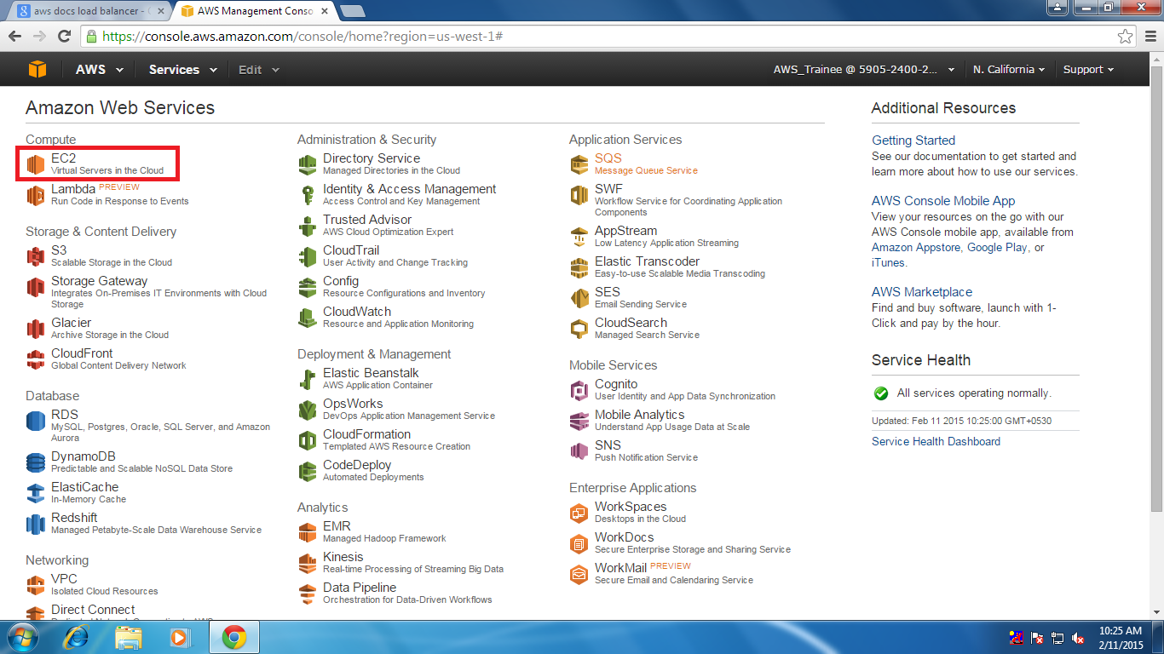

2. Int that we want to select ec2 after that we can see a page in that page we want to click on launch instance

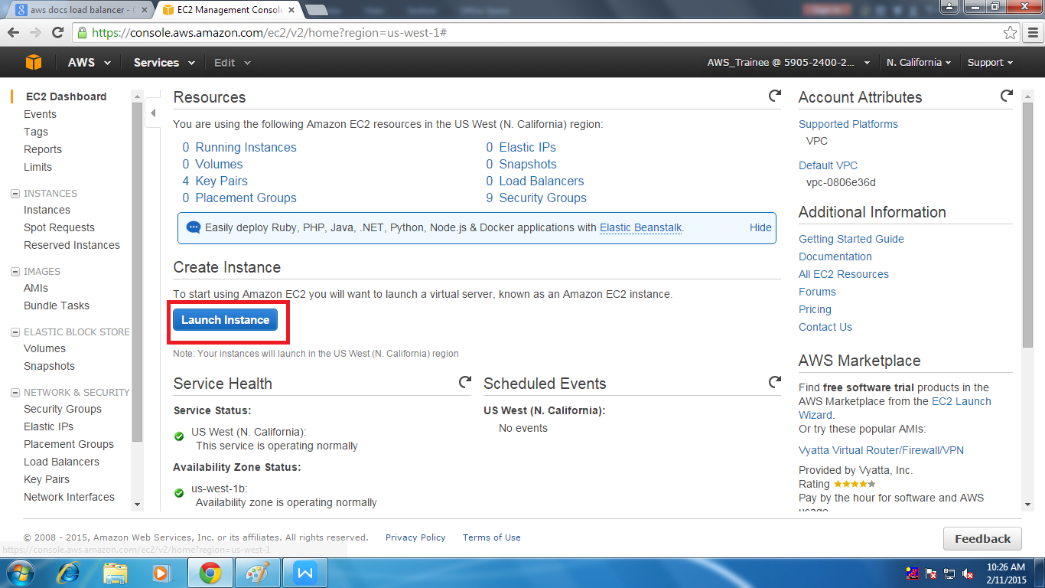

3. After that step we will see page where we want to select the type of instance which we want to use after selecting the type we want to click on configure instance details

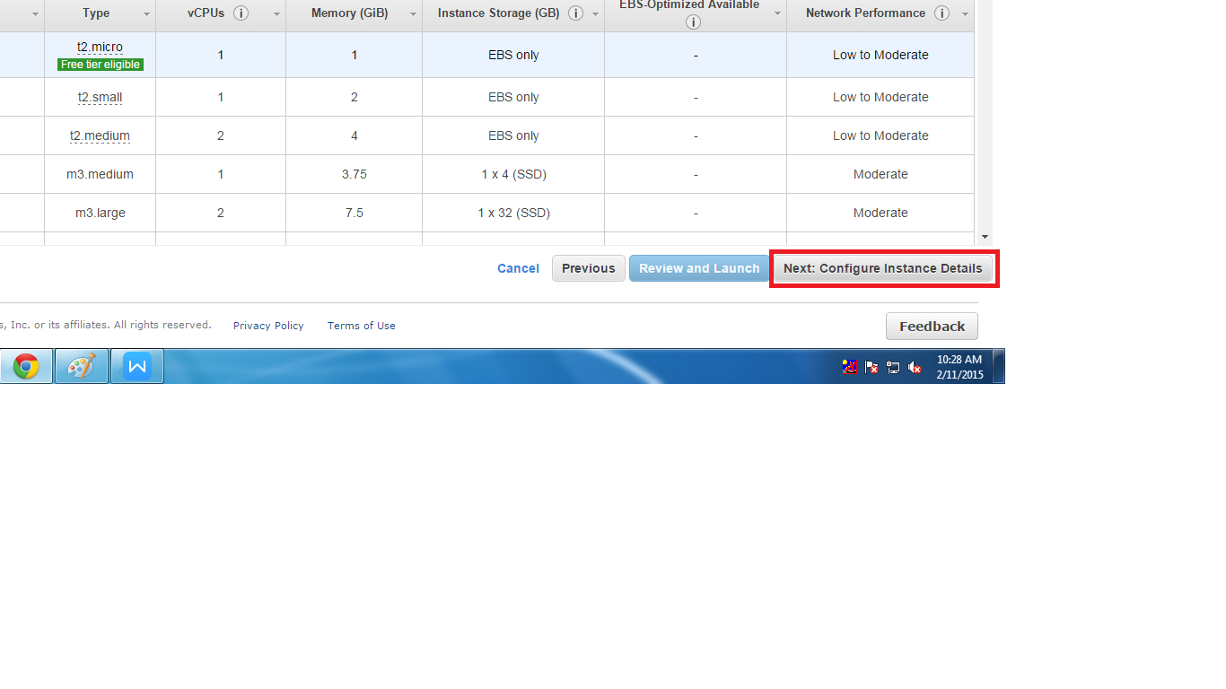

4. When complete the above step we can see a page where we can do some configuration like changing VPC & SUBNET

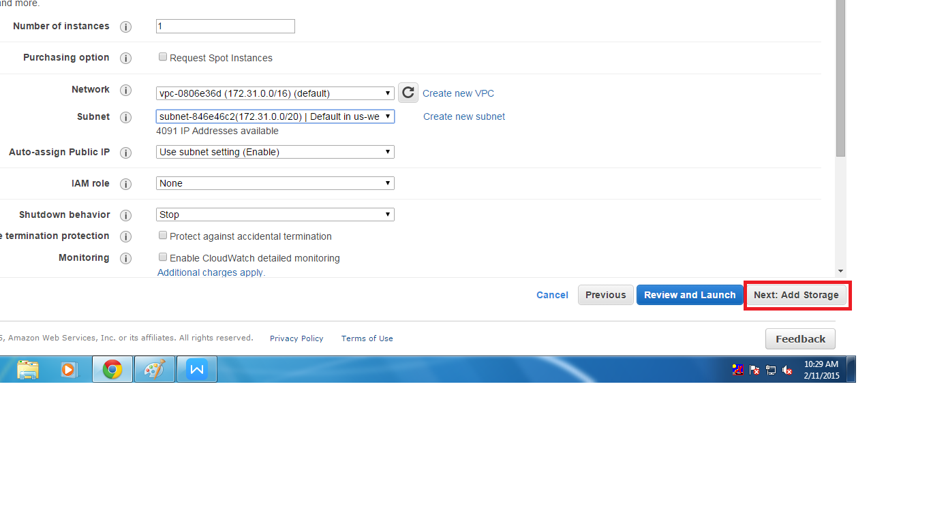

5. In the next step we can see the the storage detail where we can also add extra volume for increases the size

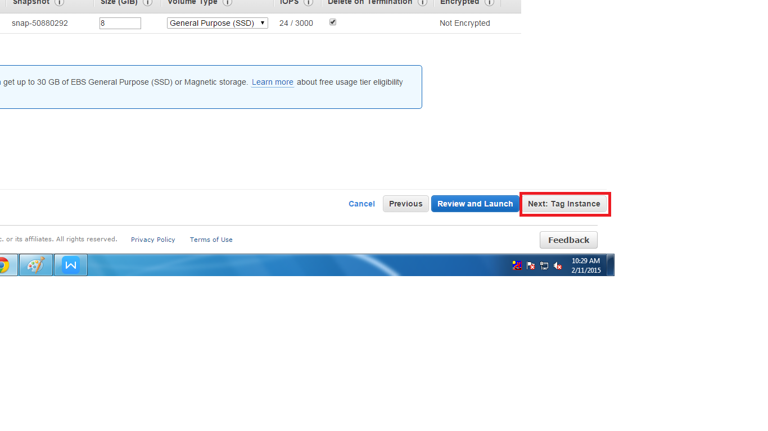

6. In the next step we have to assign tag to the instance that means NAME

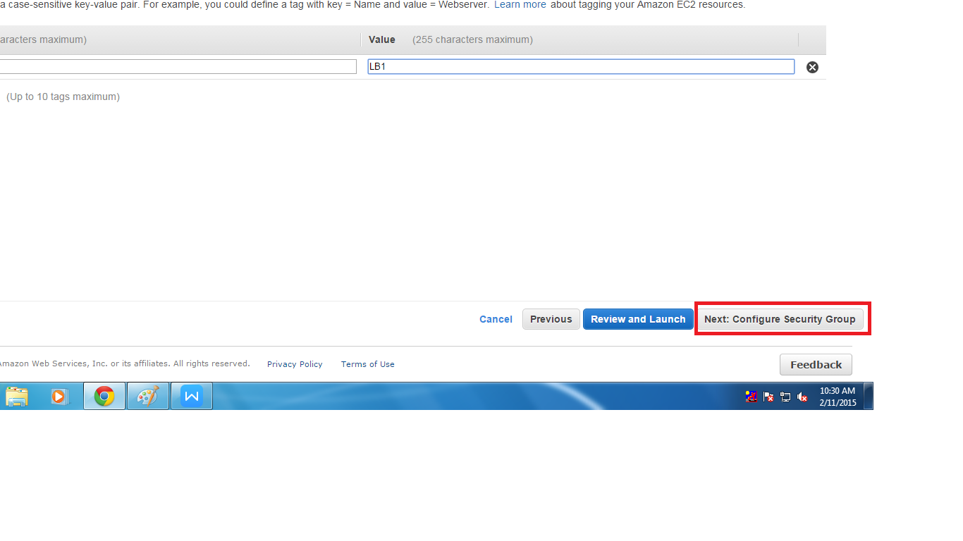

8. In the next step we have assign security group her we can create new one or we can use existing one also

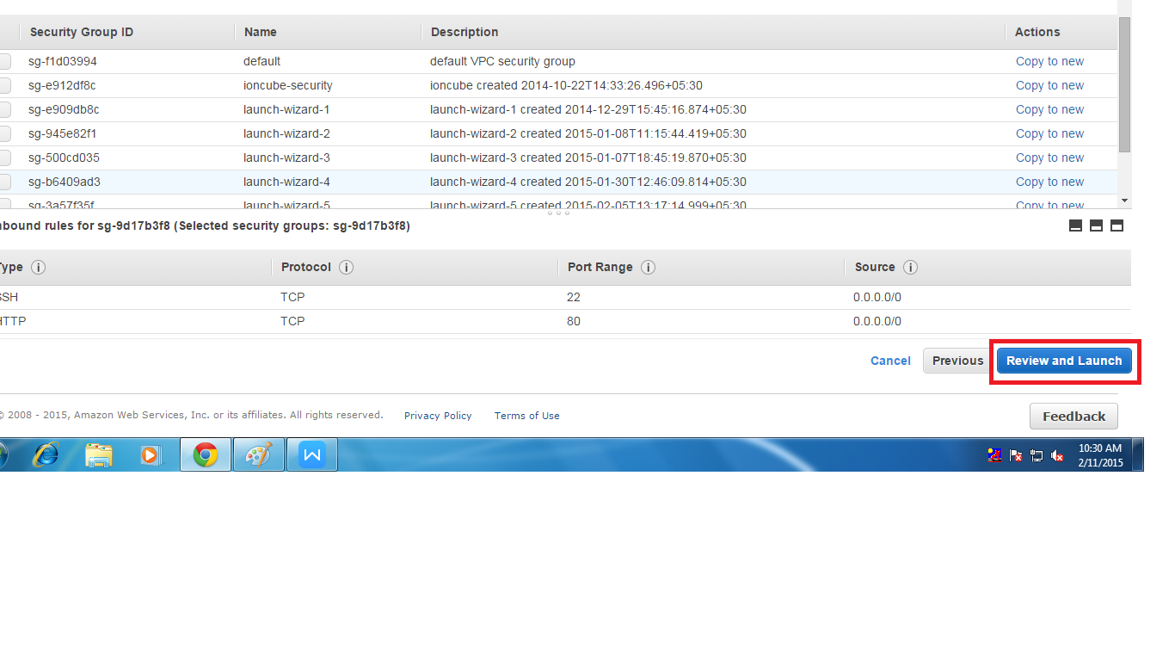

8. In this we get to see the total summary detail of the instance which we are creating

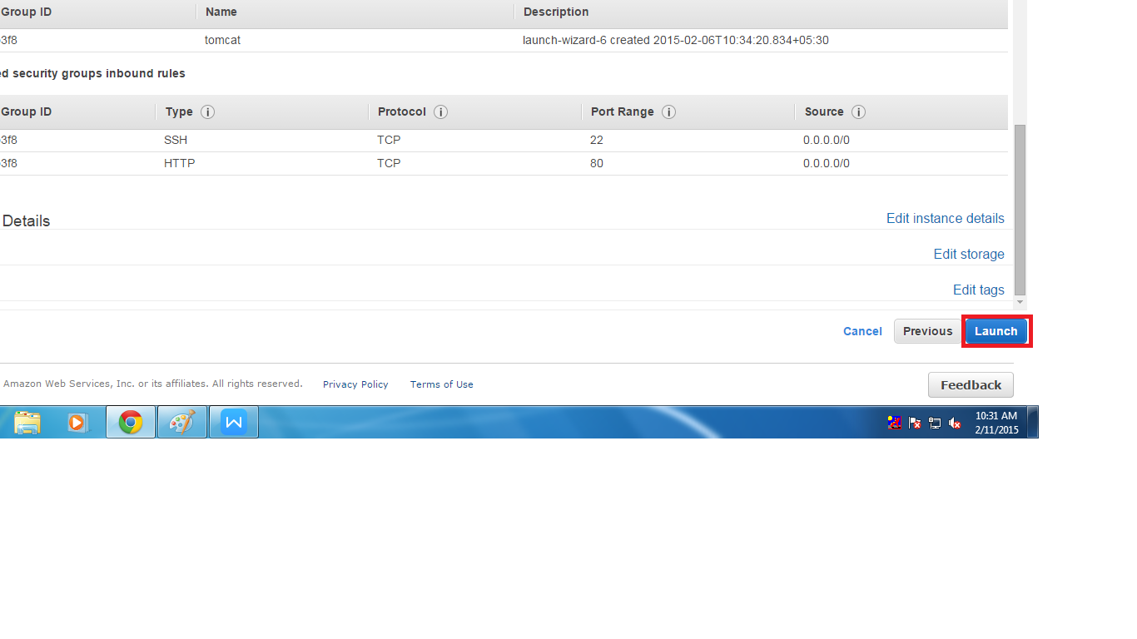

9. After press launch thane we will see a page where we have to create private key pair if we need we have to create new one other wish we can also use existing one

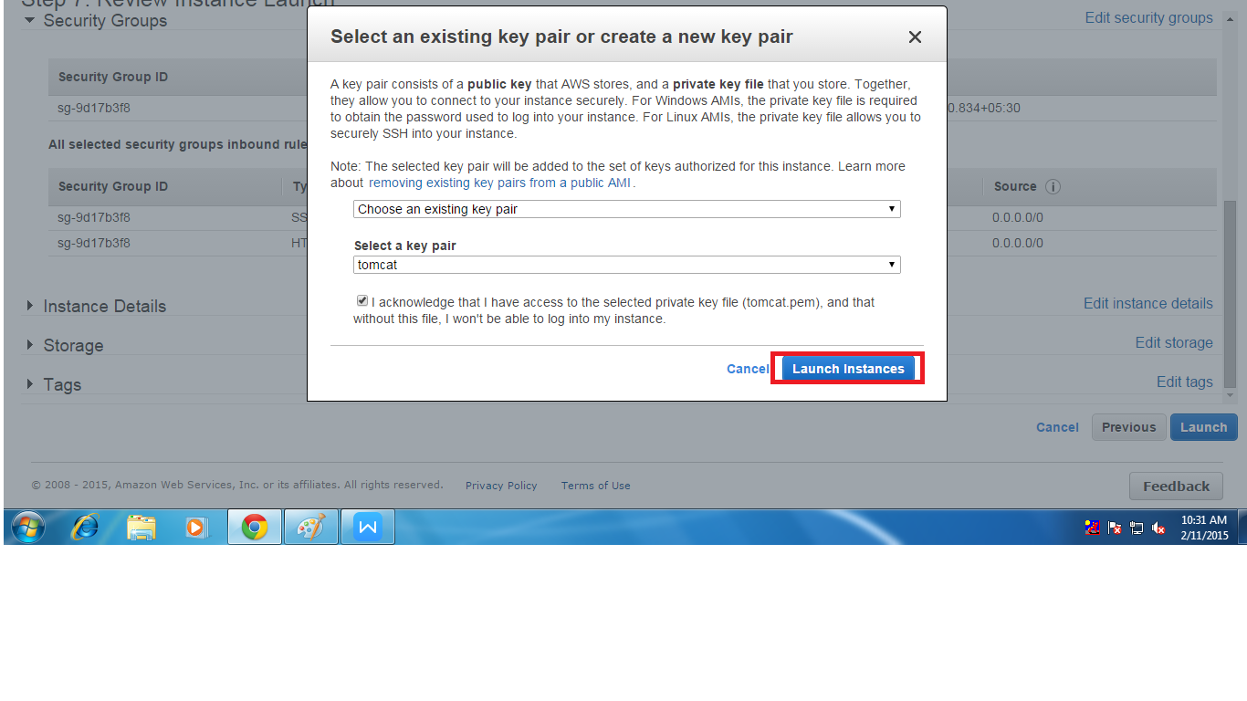

10. After creating the key pair we have click on launch instance than we can see the instance on instance page .For Load Balancing we need two instance so by using above process we can create another instance (or) ‘n’ number of instance

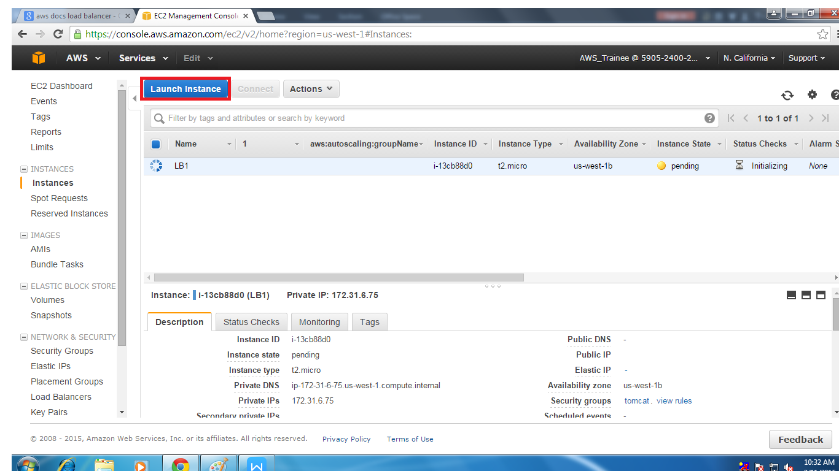

* After creating two instance we have go the navigational plane in instance page after that we have to select the LOAD BALANCE

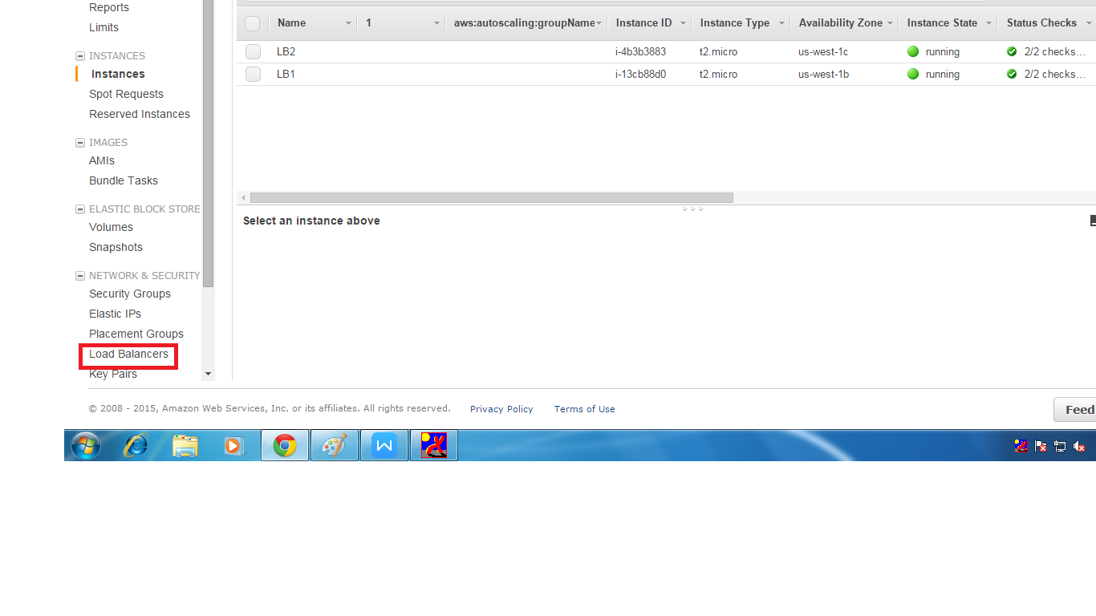

* Than we can see a page where we get a option to create LOAD BALANCE than by creating that option we can start creating the load balancer

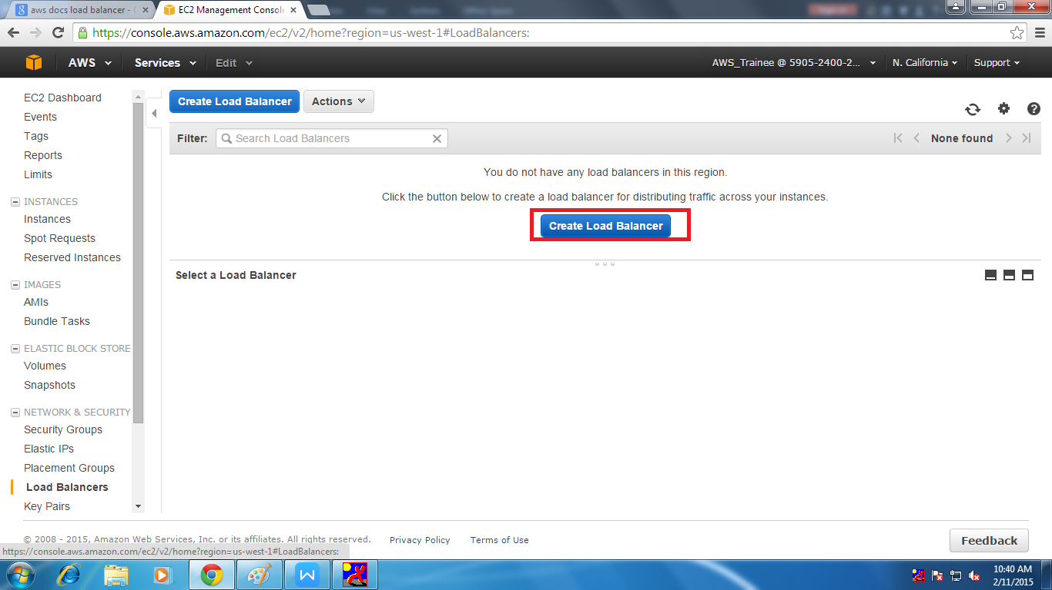

* When we select that option we can see a page where we have to assign name for the load balancer ,assigning vpc and also assigning load balancer protocol and select continue.

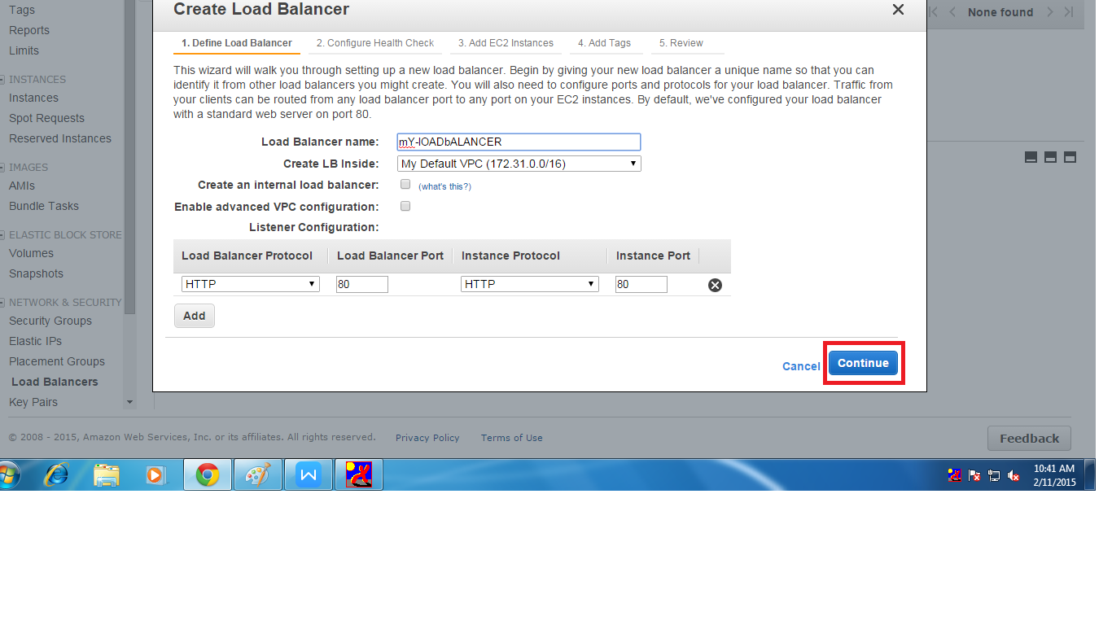

* In the next page we have to configure Health check to perform health check on instance which we add to the load balancer .Here we have to set ping protocol should be TCP.

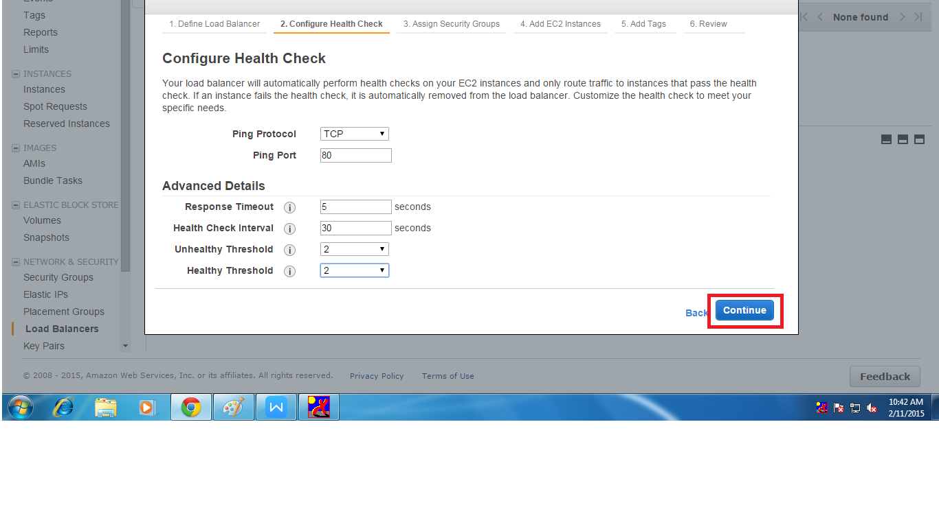

* After that we have to create security group or use the existing security group

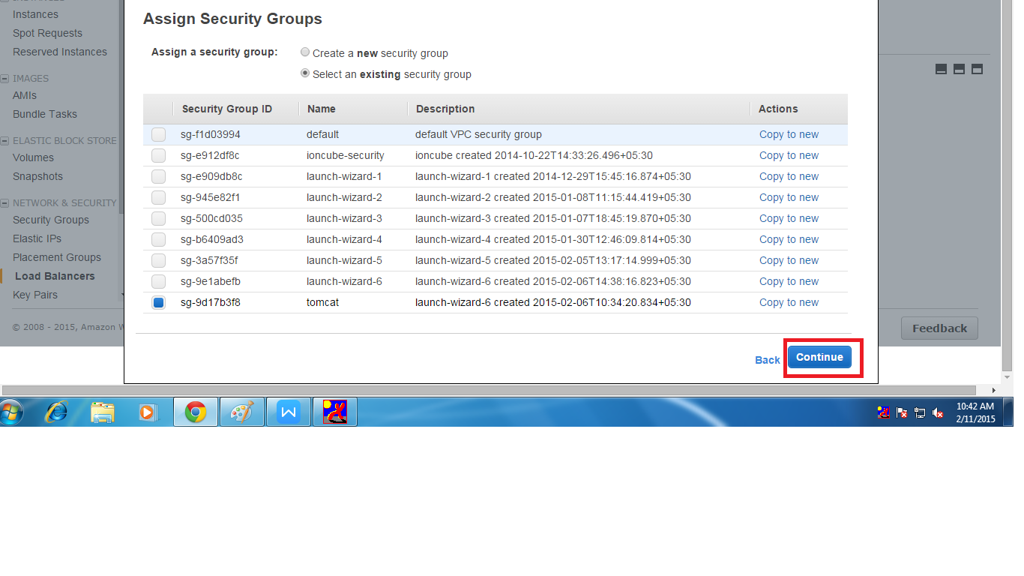

* After that we have to add the instance to the load balancer

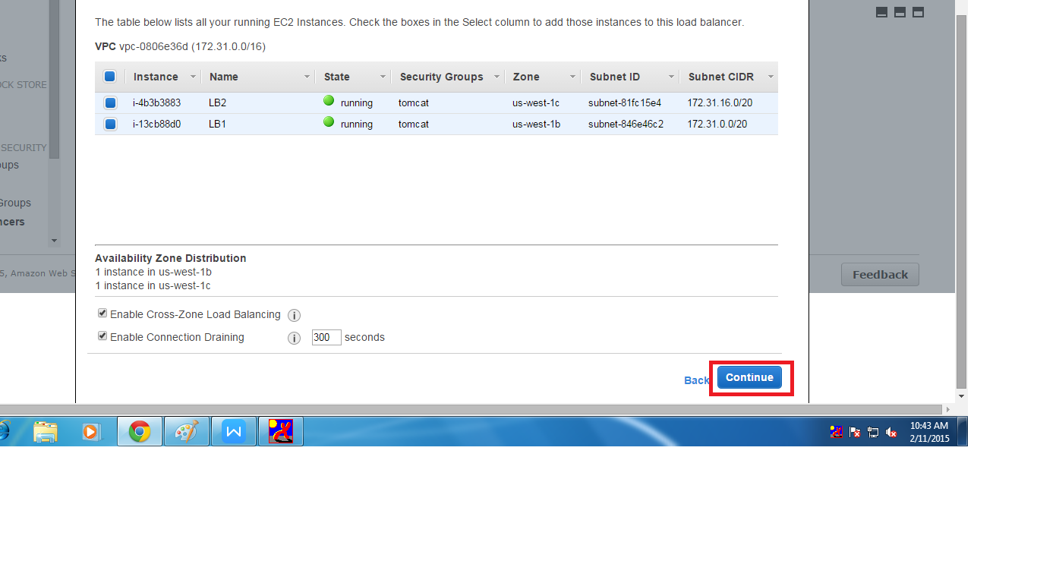

* Than we have to add tag to the load balancer that means name.

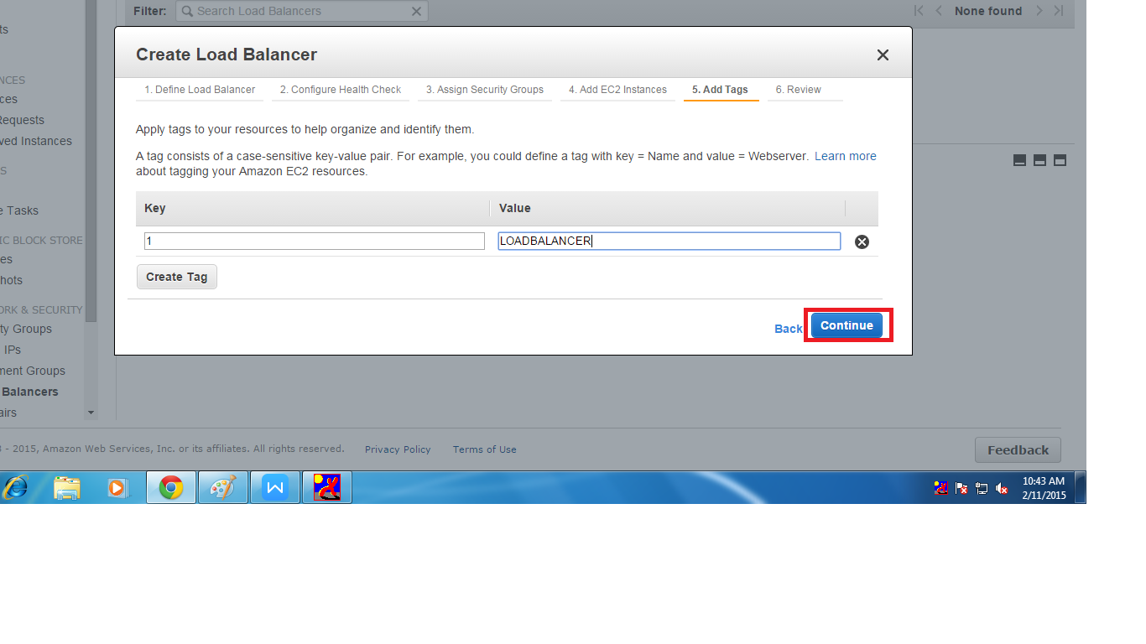

* In this step we will see the summary of the load balancer . Than click on create.

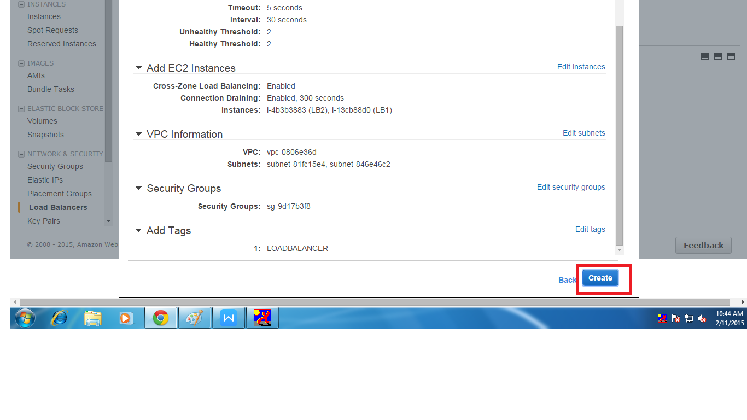

* To check whether load balancer is working or not we have to see the status of the instance in Description of the load balancer it should be (2 of 2) means no of instance which we added are in completely in service

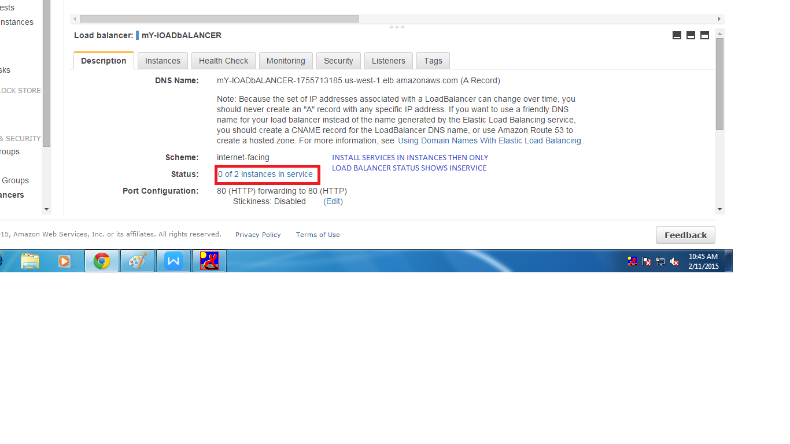

* Load balance work when there is any application working in the instance which are present in the load balancer .We can say applications like apache than let see how to accese the instance and installing application

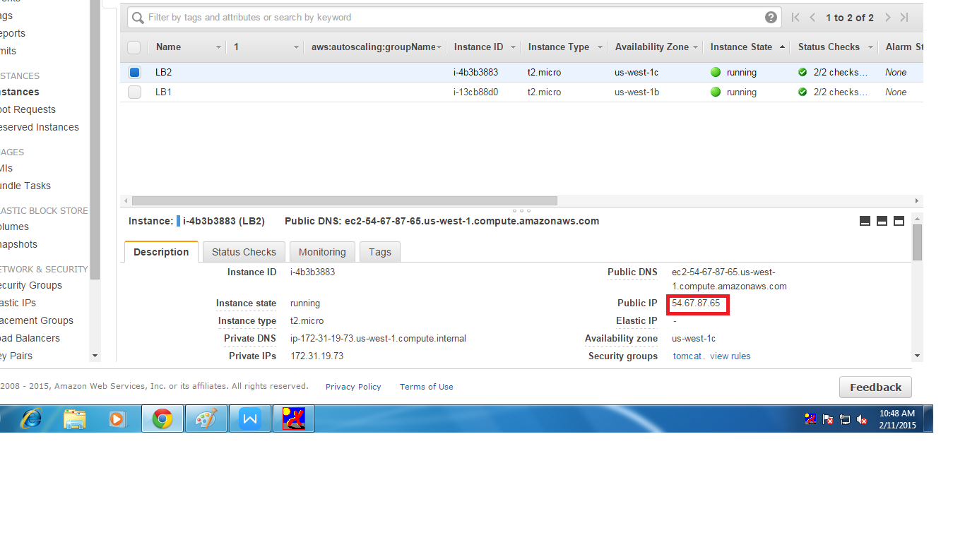

* By using putty we can assces the ec2 instance and by using command and install application . At the end of the document we can see the two instance are in service after installing the applicition .And aslo we can check the load balancer is working or not by giving the public ips of the instances in the browser URL

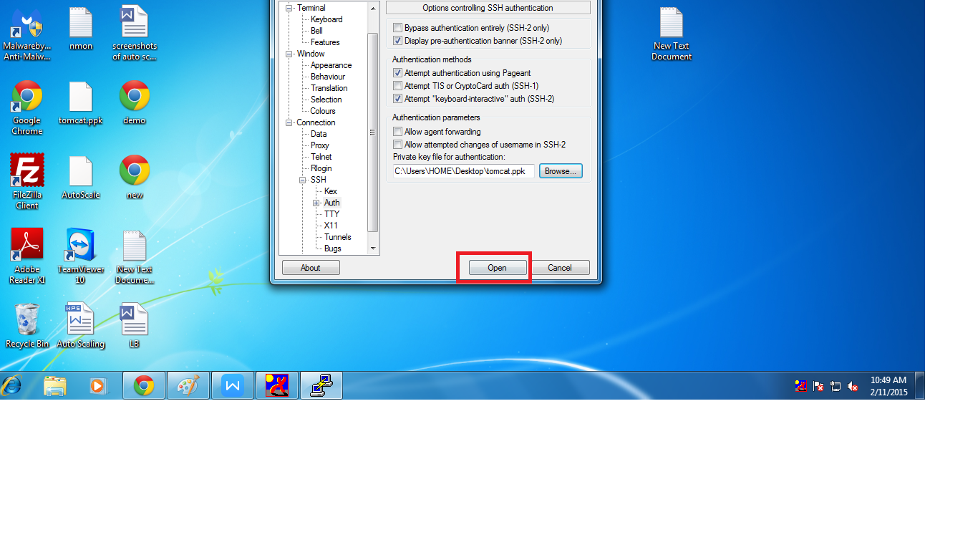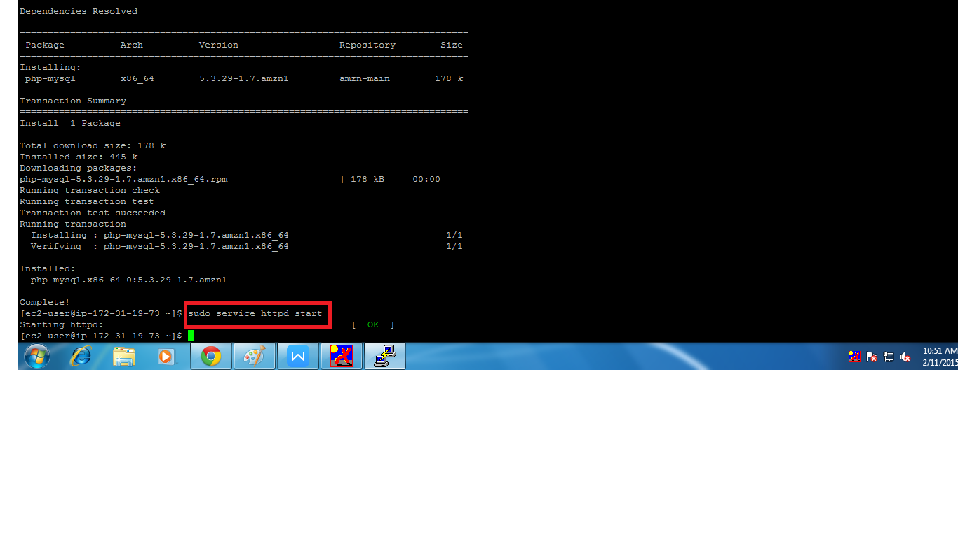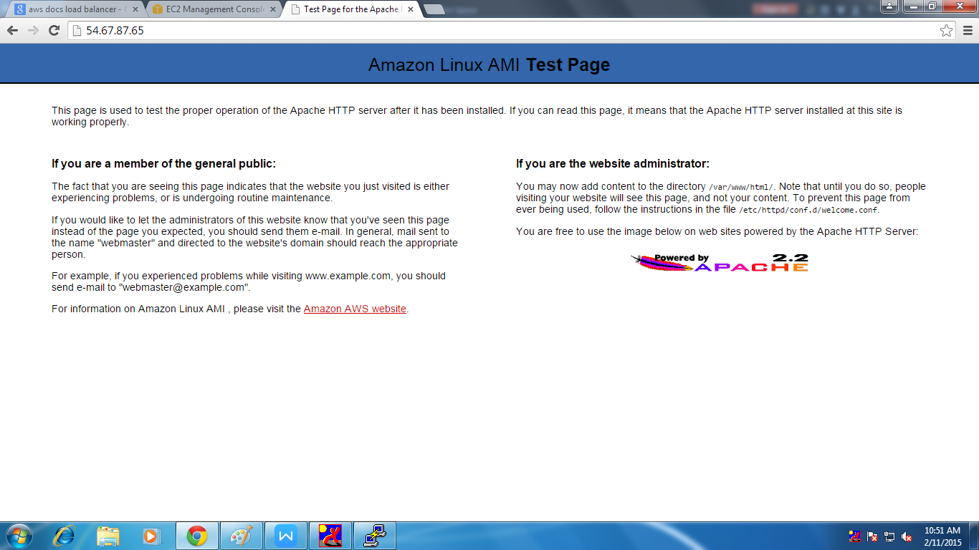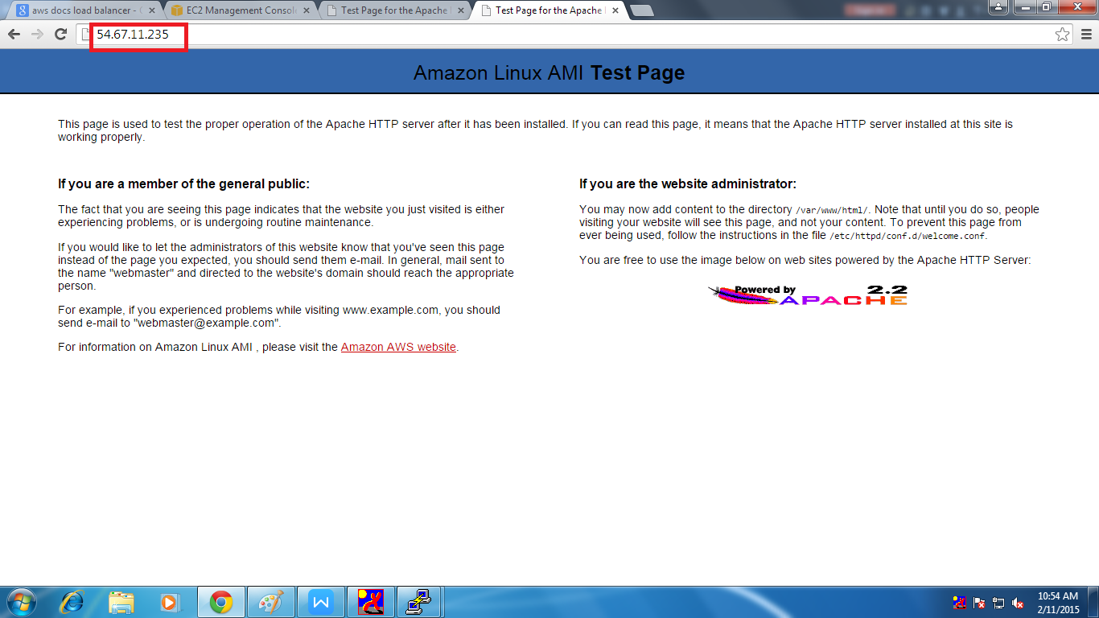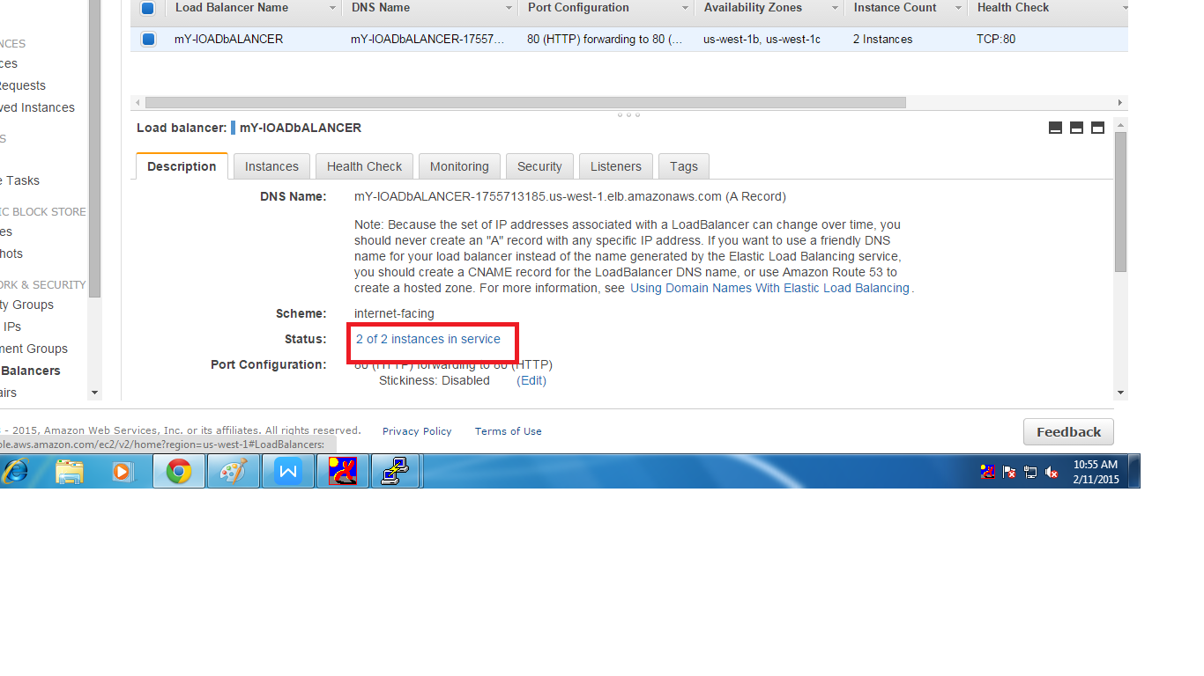

* In this page we can see that two instance are in service.

